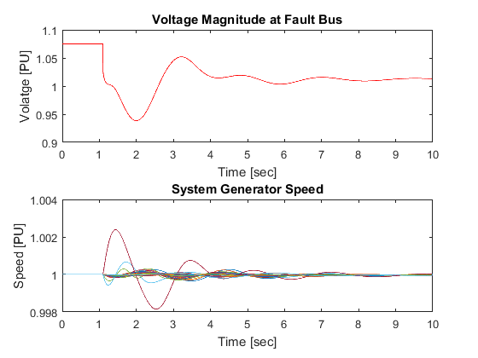

pstV3p1 – sim elapsed time = 50.2106s

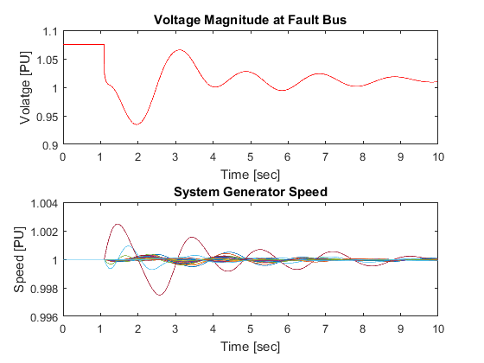

pstV2P3 - elapsed time = 50.8042s

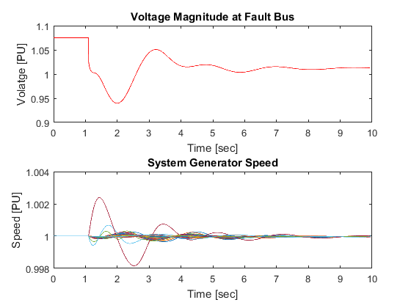

pstSETO - elapsed time = 24.9605s

(no live plot - elapsed time = 16.8189s)